The wrong equations. Please note the red box below:
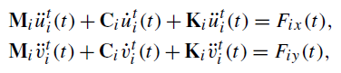

The correct equations. Please note the green box below:
$M_{i}{\ddot{u}}_{i}^{t}\left(t\right)+C_{i}{\dot{u}}_{i}^{t}\left(t\right)+K_{i}u_{i}^{t}\left(t\right)=F_{ix}(t)$ (1)

$M_{i}{\ddot{v}}_{i}^{t}\left(t\right)+C_{i}{\dot{v}}_{i}^{t}\left(t\right)+K_{i}v_{i}^{t}\left(t\right)=F_{iy}(t)$ (2)

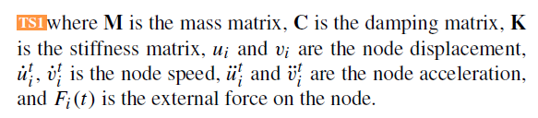

Explanation: The dynamic balance equation usually consists of three parts. Mass (M) multiplied by acceleration, damping (C) multiplied by velocity, stiffness (K) multiplied by displacement, the result is the unit of force.
So, the third part of equation (1) and (2), stiffness (K) cannot be multiplied by acceleration. Stiffness (K) multiplied by displacement is the unit of force.

