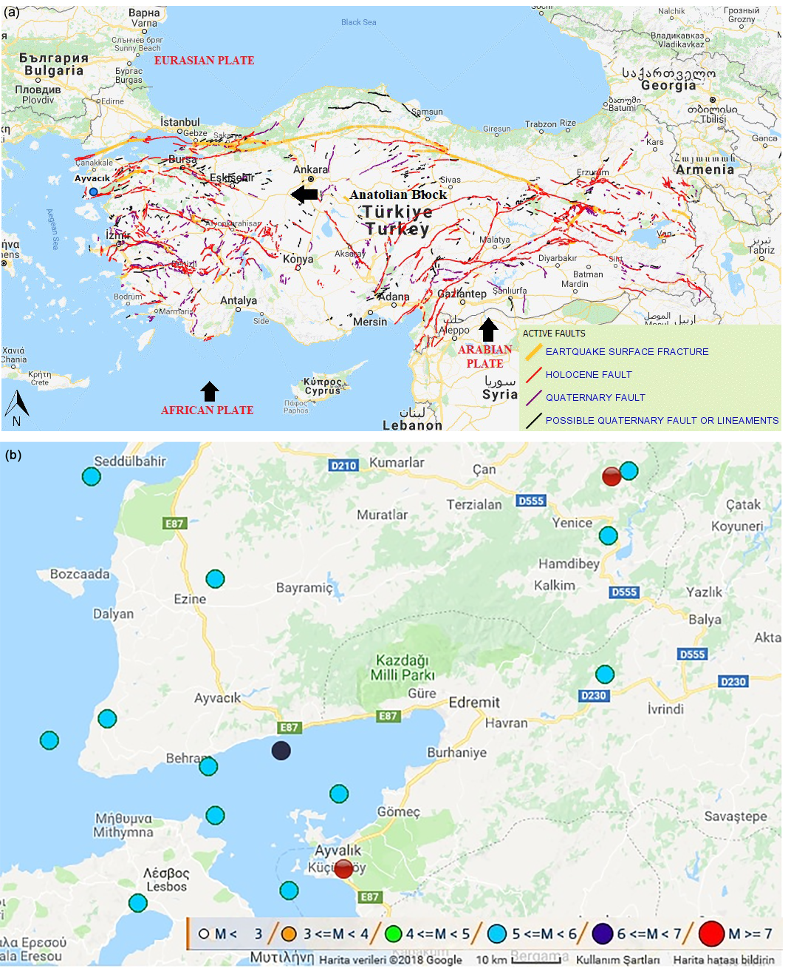

Figure 5. (a) Active fault map of Turkey (MRE, 2018). (b) The most powerful earthquake within the instrumental period around Ayvacık .region.

